13
J AND K INVERTERS AND EQUATIONS
FOR COUPLED LINES

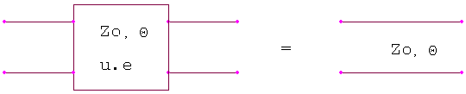

A B 1 sZ_{o}
= 1/√(1-s²)
C D s/Z_{o} 1

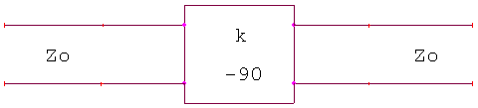

14
For J inverter,
A B 0 j/J
=
C D _{J} jJ 0

Z_{oe} = Z_{o} [1 + JZ_{o} +(JZ)² ]
Z_{oo} = Z_{o} [1 - JZ_{o} +(JZ)² ]

For K inverter,
Z_{oe} = Z_{o} [1 + J/K +(J/K)² ]
Z_{oo} = Z_{o} [1 - J/K +(J/K)² ]

Richards Transformation

Z_{in} = Z_{o} / j tanΘ= Z_{o} /s C = 1/Z_{o}

Z_{in} = Z_{o} * j tanѲ = Z_{o} s
L = Z_{o}

Coupled Lines
Z_{o}J₁ = (Dπ / 2g₁)^{½}
Z_{o}J_{n} =  πD / 2(g_{n+1} g_{n})^{½}
Z_{o}J_{n+1} = (Dπ / 2g_{n} g_{n+1})^{½}

Where,
D ( Fractional bandwidth ) = (w ₂- w ₁)/ w ₀

