1

1. Series Impedance Element

[A B =[ 1 Z
C D] 0 1]

2. SHUNT ADMITTANCE Element

[A B =[ 1 0
C D] y 1]

3. LOSSLESS TRANSMISSION LINE

[A B =[ cosβl jZ₀sinβl
C D] jsinβl/Z₀ cosβl ]
2
4. N:1 TRANSFORMER

[A B =[ N 0
C D] 0 1/N ]

S-Parmeters of Lossless Transmission Line

SINCE THE TRANSMISION LINE IS LOSSLESS, α=0
THEREFORE

[S]= [ O exp(-jβl)

exp(-jβl) 0 ]

3

This structure can be implemented in stripline as

(Main inductance with side capacitances)
Where
jZ₀sinβl=jwL

4

This is realized in stripline as
(Main capacitance with side inductances)
Where
jZ₀sinβl=1/(jwC)

From the above two equations we can find out the length l.
For inductance element, we use higher impedance (Z₀ = 100Ω for stripline)

For capacitance element, we use lower impedance (Z₀ = 20Ω for stripline)

Hence, for any inductor or capacitor, the width stays same, only length varies depending on L or C values.

Put jTanβl=s
Then the short circuit and open circuit impedances become

Z_{sc}=jZ₀tanβl=Z₀s
Z_{oc}=Z₀/jTanβl=Z₀/s
5
When this is compared with the reactance of an inductor and susceptance of a capacitor respectively, it’s seen that an inductor L can be represented by a short circuited stub and a capacitor C can be represented by an open circuited stub as shown below.

Here the length of the stub is always the same as shown but the width w varies depending on the L or C value.

ABCD PARAMETERS IN GENERAL
For reciprocal network, AD – BC = 1
If a network is symmetrical, A = D
For a lossless network, A and D are real
B and C are imaginary
6
Z_{i1} = √AB/CD
Z_{i2} = √BD/AC
Z_{input} = (AZ_{L} + B)/(CZ_{L} + D)

RELATIONSHIP OF ABCD WITH
S-PARAMETERS
S₁₁ = (A + B/Z₀ – CZ₀ – D)/∆
S₁₂ = 2(AD – BC)/∆
S₂₁ = 2/∆
S₂₂ = ( -A + B/Z₀ – CZ₀ + D)/∆

Where, ∆ = A + B/Z₀ + CZ₀ + D

FILTER REALISATION
BUTTERWORTH FILTER OR MAXIMALLY FLAT FILTER
L (dB) = 10log (1 + ω^{2n} )
L_{a} = 3 dB for a butterworth response
g_{n} values for a Butterworth Response:
g₀ = 1
g₁ = 2 sin [ (2k-1)/2n ] ; k=1,2,3….n
g_{n+1} = 1
7
CHEBYCHEV FILTER OR EQUIRIPPLE FILTER
A = 10log [1 + (10^{Am/10} – 1) cos² (ncos⁻¹ω’) ]
Where,
n = order of the filter
A_{m} = Ripple Magnitude in dB
ω’ = Bandwidth over which the insertion loss has maximum ripple
Here,
ω’ = ω/ω₀ for a Low Pass Filter
ω’ = Q(ω/ω₀ - ω₀/ω) for a Bandpass Filter
ω’ = - ω₀/ω for a High Pass Filter

g_{n} values for Chebychev Response:
g₀ = 1
g₁ = 2a₁/γ
g_{k} = 4a_{k}a_{k-1}/b_{k-1}g_{k-1} ; k=2,3,4….n
g_{n+1} = 1 ; n-odd
g_{n+1} = tanh²(β/4) ; n-even
where,
a_{k} = sin{(2k-1)π/2n} ; k=1,2….n
b_{k} = γ² + sin²(kπ/n) ; k=1,2,…n
β = ln[coth A_{m}/17.37]
γ = sinh (β/2n)

8
STATIC Analysis

Static analysis produces T.L. (Transmission Lines ) parameters which are frequency independent.
Z_{o} = (L/C)^{½}
where L is the inductance / unit length of the transmission line and
C is the capacitance/ unit length of the transmission line .
Z_{o}= (L_{a} C_{a} / C C_{a}) ^{½}
where L_{a} is the inductance / unit length of the transmission line and
C_{a} is the capacitance/ unit length of the transmission line , when the dielectrics are replaced by air i.e. €_{r} =1.

Z_{o}= 1/c(C C_{a}) ^{½}
[ Inductance/unit length does not depend on the surrounding substrate. ]
where c= velocity of light in free space.

The phase velocity n_{p} of the QUASI-TEM wave propagating along the transmission line is given as

n_{p}= c/(ε_{eff})^{½}

ε_{eff} = c² / n_{p}² = C /C_{a}

Wavelength λ= λ _{o} /(ε_{eff})^{½}

LAPLACE EQUATIONS are to be solved for C calculation.

TO DETERMINE STATIC PARAMETERS , we only need to calculate
C/unit length of Transmission Line with and without SUBSTRATE.

9
Hybrid Ring Coupler
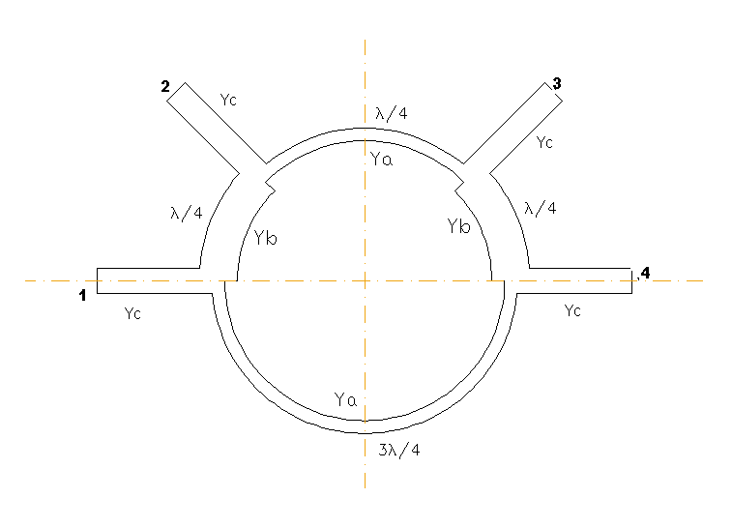
Scattering Matrix characterizing the matched hybrid ring is given by

0 -jY_{b}/Y_{c} 0 jY_{a}/Y_{c}
-jY_{b}/Y_{c} 0 -jY_{a}/Y_{c} 0
0 -jY_{a}/Y_{c} 0 -jY_{b}/Y_{c}
jY_{a}/Y_{c} 0 -jY_{b}/Y_{c} 0

(Y_{a}/Y_{c})²+(Y_{b}/Y_{c})²=1,

Scattering Matrix of the rat-race hybrid is given by

0 -j/√2 0 j/√2
-j/√2 0 -j/√2 0
0 -j/√2 0 -j/√2
j/√2 0 -j/√2 0

10
Two-Stub Branch Line Coupler

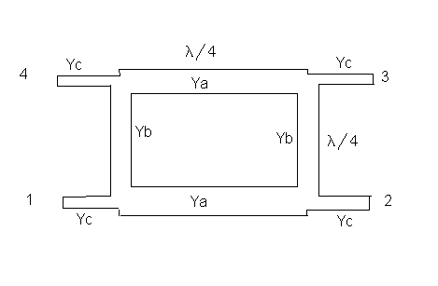

For S₁₁=0, BY_{c}=C/Y_{c}

Mid-Band Parameters:
S₁₁=S₁₄=0, S₁₂=-jY_{c}/Y_{a}, S₁₃=-jY_{b}/Y_{a}
Y_{c}²=Y_{a}²-Y_{b}²

For 10dB,90⁰ Coupler
S₁₂=-j3/√10, S₁₃=-1/√10
Y_{a}=√10Y_{c}/3, Y_{b}=Y_{c}/3

11
Two-way Power divider

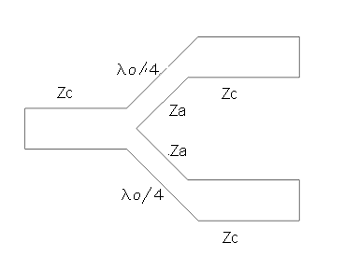
Z_{a}=√2Z_{c}

Scattering Matrix can be written as
0 1/√2 1/√2
1/√2 S₂₂ -S₂₂
1/√2 -S₂₂ S₂₂

|S₂₂|=1/2
Matched Power Divider

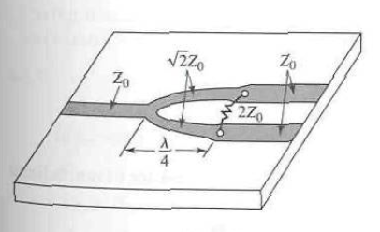
12
Overall Scattering matrix of the Matched Power divider is
0 -j/√2 -j/√2
-j/√2 0 0
-j/√2 0 0

Unequal Power Divider
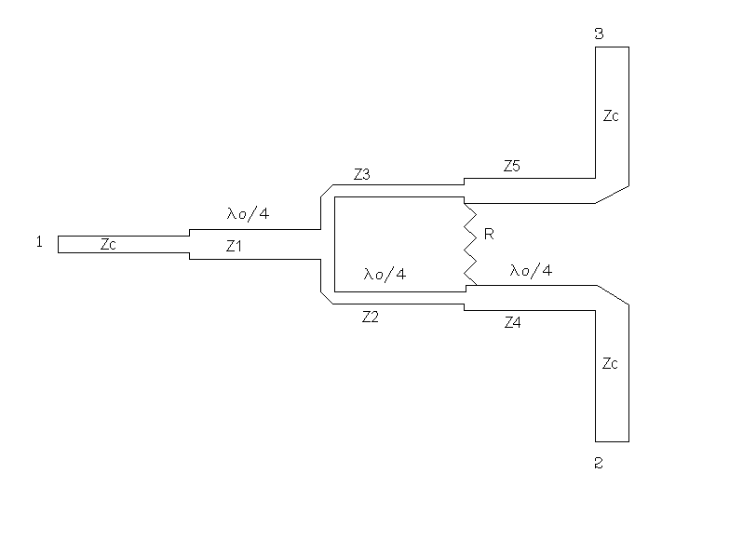
Design forumulas for this power divider are as follows
P₃/P₂=K²
Z₁=Z_{c}(K/1+K²)^{1/4}
Z₂=Z_{c}K^{3/4}(1+K²)^{1/4}
Z₃=Z_{c}(1+K²)^{1/4}/K^{5/4}
Z₄=Z_{c}√K
Z5=Z_{c/}√K
R=Z_{c}(1+K²/K)

NEXT

